CONTROL DE VERSIONES

|  |  |  |  |  |  |  |
| --- | --- | --- | --- | --- | --- | --- |
| **Versión** | **Hecha por** | **Revisada por** | **Aprobada por** | **Fecha** | **Motivo** |  |
|  |  |  |  |  |  |  |
|  |  |  |  |  |  |  |

PLAN DE GESTIÓN DE RIESGOS

|  |  |  |  |  |  |  |  |  |  |  |
| --- | --- | --- | --- | --- | --- | --- | --- | --- | --- | --- |
|  | NOMBRE DEL PROYECTO | |  | SIGLAS DEL PROYECTO | | | | |  |  |
|  |  |  | |  |  |  |  |  |  |  |
|  |  |  | | |  |  |  |  |  |  |
|  | METODOLOGÍA DE GESTIÓN DE RIESGOS | | | | |  |  |  |  |  |
|  |  |  |  |  |  |  |  |  |  |  |
|  | **PROCESO** |  | **DESCRIPCIÓN** | |  |  | **HERRAMIENTAS** |  | **FUENTES DE** |  |
|  |  |  |  |  | **INFORMACIÓN** |  |
|  |  |  |  |  |  |  |  |  |  |
|  |  |  |  |  |  |  |  |  |  |  |
|  |  |  |  |  |  |  |  |  |  |  |
|  |  |  |  |  |  |  |  |  |  |  |
|  |  |  |  |  |  |  |  |  |  |  |
|  |  |  |  |  |  |  |  |  |  |  |



ROLES Y RESPONSABILIDADES DE GESTIÓN DE RIESGOS

|  |  |  |  |  |  |  |
| --- | --- | --- | --- | --- | --- | --- |
|  | **PROCESO** | **ROLES** | **PERSONAS** | **RESPONSABILIDADES** | |  |
|  |  |  |  |  |  |  |
|  |  |  |  |  |  |  |
|  |  |  |  |  |  |  |
|  |  |  |  |  |  |  |
|  |  |  |  |  |  |  |
|  |  |  |  |  |  |  |
|  |  |  |  |  |  |  |

PRESUPUESTO DE GESTIÓN DE RIESGOS

|  |  |  |  |  |  |  |  |  |  |  |
| --- | --- | --- | --- | --- | --- | --- | --- | --- | --- | --- |
| **PROCESO** | **PERSONAS** | | | **MATERIALES** | | | **EQUIPOS** | | | **TOTAL** |
|  |  |  |  |  |  |  |  |  |  |  |
|  |  |  |  |  |  |  |  |  |  |  |
|  |  |  |  |  |  |  |  |  |  |  |
|  |  |  |  |  |  |  |  |  |  |  |
|  |  |  |  |  |  |  |  |  |  |  |
|  |  |  |  |  |  |  |  |  |  |  |
|  |  |  |  |  |  |  |  |  |  |  |
|  |  |  |  |  |  |  |  |  |  |  |
|  |  |  |  |  |  |  |  |  |  |  |
|  |  |  |  |  |  |  |  |  |  |  |
|  |  |  |  |  |  |  |  |  |  |  |

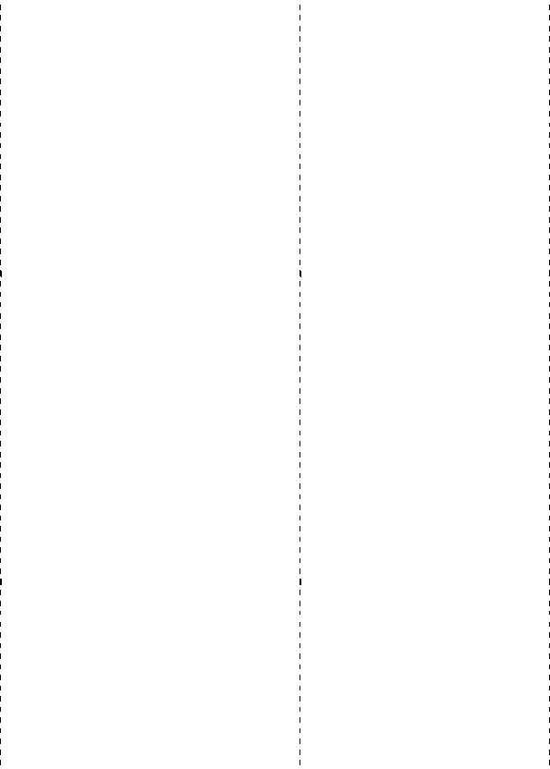

PERIODICIDAD DE LA GESTIÓN DE RIESGOS

|  |  |  |  |  |  |  |  |
| --- | --- | --- | --- | --- | --- | --- | --- |
| **PROCESO** |  | **MOMENTO DE EJECUCIÓN** |  | **ENTREGABLE DEL** | **PERIODICIDAD DE** |  |  |
|  |  | **WBS** | **EJECUCIÓN** |  |  |
|  |  |  |  |  |  |
|  |  |  |  |  |  |  |  |
|  |  |  |  |  |  |  |  |
|  |  |  |  |  |  |  |  |
|  |  |  |  |  |  |  |  |
|  |  |  |  |  |  |  |  |
|  |  |  |  |  |  |  |  |

FORMATOS DE LA GESTIÓN DE RIESGOS

|  |  |  |  |  |  |  |  |  |  |  |  |  |  |
| --- | --- | --- | --- | --- | --- | --- | --- | --- | --- | --- | --- | --- | --- |
| **FORMATO** |  | **CONTENIDO** |  |  | **PROCESO EN QUE** |  |  | **RESPONSABLE DE** |  |  | **FRECUENCIA O** |  |  |
|  |  |  | **SE GENERA** |  |  | **GENERARLO** |  |  | **PERIODICIDAD** |  |  |
|  |  |  |  |  |  |  |  |  |  |  |
|  |  |  |  |  |  |  |  |  |  |  |  |  |  |
|  |  |  |  |  |  |  |  |  |  |  |  |  |  |
|  |  |  |  |  |  |  |  |  |  |  |  |  |  |
|  |  |  |  |  |  |  |  |  |  |  |  |  |  |
|  |  |  |  |  |  |  |  |  |  |  |  |  |  |